**Ideation Phase**

**Brainstorm & Idea Prioritization**

| Date | 30 August 2025 |
| --- | --- |
| Team ID | LTVIP2025TMID60971 |
| Project Name | DocSpot: Seamless Appointment Booking for Health |
| Maximum Marks | 4 Marks |

## Brainstorm & Idea Prioritization Template:

Brainstorming provides a free and open environment that encourages everyone within a team to participate in the creative thinking process that leads to problem solving. Prioritizing volume over value, out-of-the-box ideas are welcome and built upon, and all participants are encouraged to collaborate, helping each other develop a rich amount of creative solutions.

### **Step-1: Team Gathering, Collaboration and Select the Problem Statement**

Problem Statement: Patients face difficulty in booking and managing appointments with doctors. Long waiting times, lack of real-time availability, and manual scheduling create inefficiencies. A seamless digital solution is needed to streamline this process.

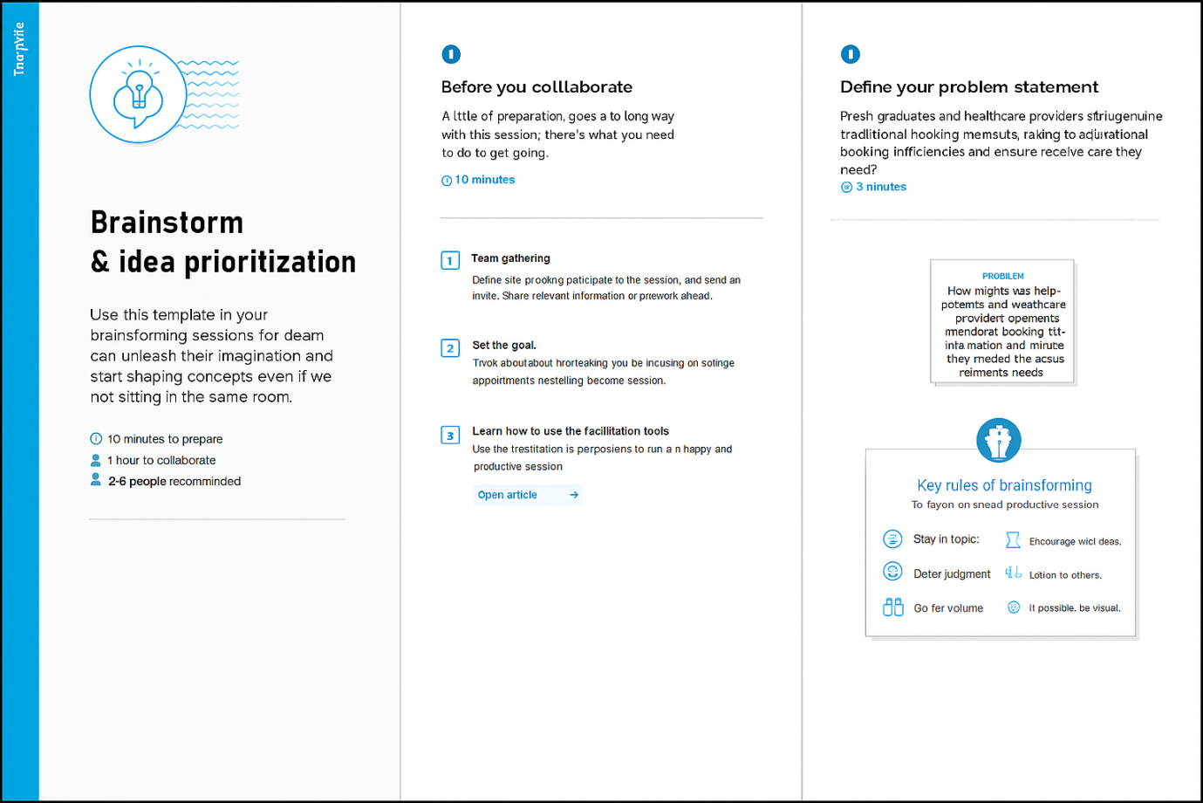

### **Step-2: Brainstorm, Idea Listing and Grouping**

**Ideas Generated:**

• Real-time appointment booking system.  
• Doctor availability calendar with instant updates.  
• Patient reminders via SMS/Email/Push Notifications.  
• Easy rescheduling and cancellation.  
• Teleconsultation/video appointment integration.  
• Secure patient data management.  
• Integration with hospital management systems.

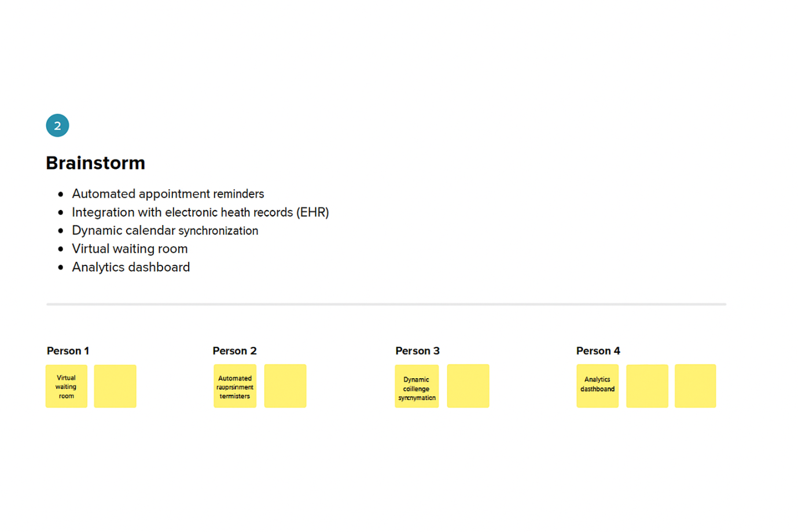

### **Step-3: Idea Prioritization**

Prioritization Criteria: Impact, Feasibility, and User Value.  
  
High Priority Ideas:  
1. Real-time appointment booking.  
2. Doctor availability calendar.  
3. Patient reminders and notifications.  
4. Easy rescheduling/cancellation.  
  
Medium Priority Ideas:  
5. Teleconsultation/video call integration.  
6. Integration with hospital systems.  
  
Low Priority Ideas:  
7. Advanced analytics dashboards.  
8. AI-based doctor recommendation system.

